**EXPERIMENT NO-8**

**AIM OF THE EXPERIMENT:**

Write a program on ESP32/Raspberry Pi to publish DHT11 data through MQTT protocol.

**Software Required**

Download MQTT Box from Google chrome either mobile or PC

**Procedure:-**

* Open MQTT box
* Create MQTT client
* Once create client give a MQTT client name.
* Select Protocol of MQTT/TCP
* Username & Password make it blank.
* Don’t touch the MQTT client ID
* Host Broker (.highbmq.com)
* Save

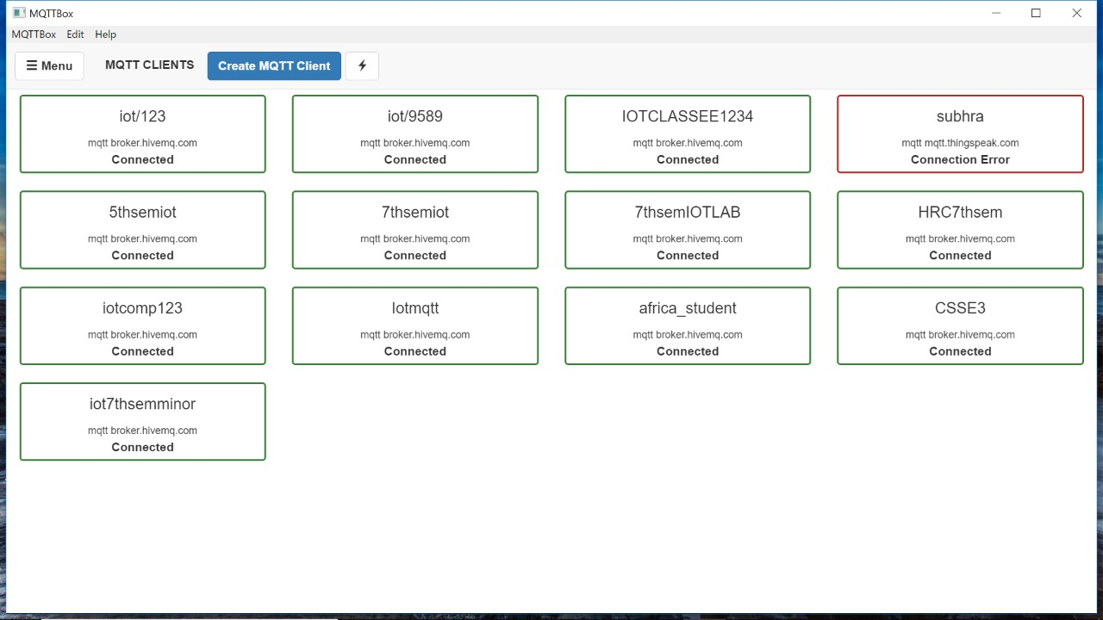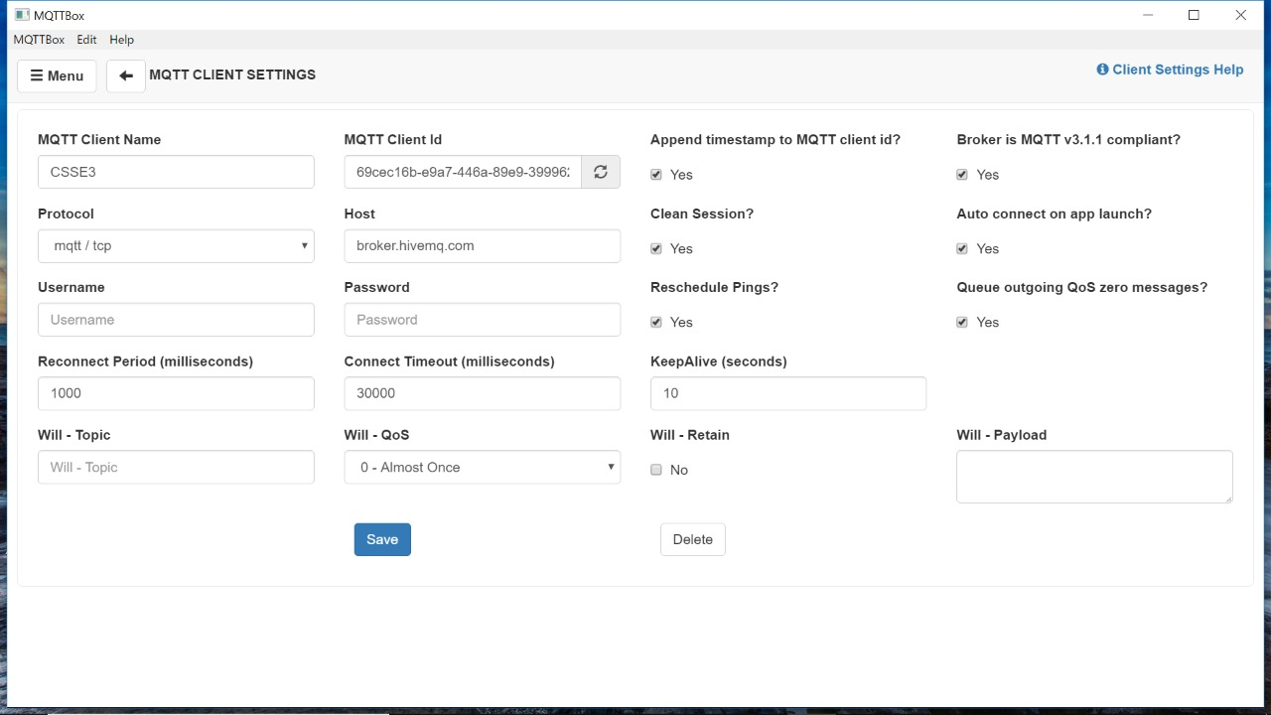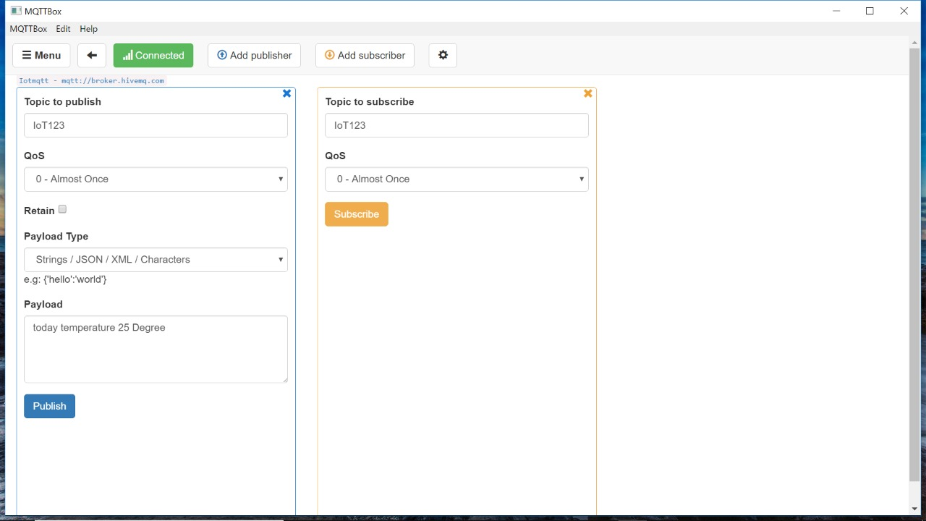

**CONCLUSION:**